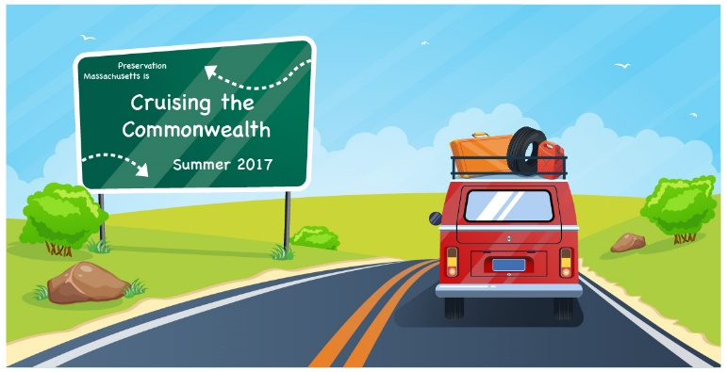
Preservation Massachusetts
Cruising the Commonwealth
Preservation “Priorities”

1.) Education: Expand and promote education, understanding and awareness about historic preservation.
-General Public: Connection and communication, how to make preservation relevant, preservation “PR”, what it really is and does.
-Schools: Preservation programs for elementary school children, foster an appreciation early on.
-Preservation “Training”: Skill labor training for preservation trades is needed.
-Ongoing educational opportunities for preservationists statewide.

2.) Building Connections & Partnerships: Staying connected, networked and growing our relationships in our communities and beyond
-Ways to keep preservation advocates/organizations networked, in touch and sharing ideas, communication is key.
-New Partnerships: Better connections to environmental, conservation and cultural groups and networks, more opportunities for sharing and collaboration.
-Outreach to “non-traditional” partners or those who don’t consider themselves “preservationists” /younger generations.
-Community involvement and engagement.

3.) Improved Access to (more) Resources and Information:
-More financial resources for preservation needed or enhanced (tax credits, grants, etc.)
-Assistance for historic homeowners (how to’s on maintenance, information, etc.)
-Model projects, success stories, best practices
-How to connect people to these resources

4.) Reactive vs. Proactive: How can we be more effective as a movement?
-Preservation without regulation – relying more on local friends and non-profit groups to advocate and encourage a preservation ethic outside of pure regulation
- Promoting preservation as a planning tool, to assist with communities needs and growth.

