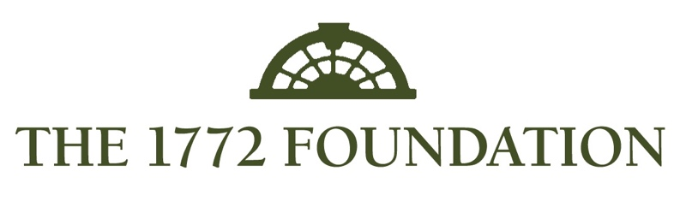
In cooperation with
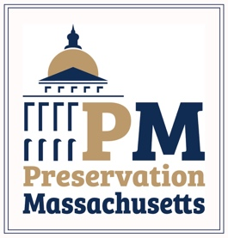
Letter of Inquiry 2023
You must answer the following questions to complete our online letter of inquiry form for the 2023 grant round. You can use this document to write and refine your answers and then “cut and paste” into our online form. There is no way to “save” your progress once you begin filling out the online form.

Before starting, please ensure that both the applicant and project meet all requirements for the grant, specifically that the applicant is a 501(c)3 organization that owns (or has a long-term lease on) the property.

1.) Name of Organization:

2.) Contact Name (this person will be the contact for all grant correspondence):

3.) Contact Mailing Address (Street, City, State, Zip).

4.) Contact Email Address:

5.) Contact Phone Number:

6.) Resource or Organization’s Website:

7.) Name of Historic Building:

8.) Address of historic site/resource (please use street, city, state, zip format):

9.) Amount of grant requested (up to $10,000):

10.) Purpose of grant: You will need to select from the following options – more than one option may be selected. All work must be exterior only.
-Exterior painting/finishes/surface restoration
-Installation or upgrade of fire detection/lightning protection/security systems
-Repairs to/restoration of porches, roofs, windows
-Structural foundation and sill repair/replacement
-Chimney/masonry repointing.

11.) Briefly describe the work this grant will fund: Be sure to review what work and projects are eligible on our program webpage. Here is where you make a compelling case for your project and historic property. Be concise, clear and convincing.

12.) What are the matching funds you plan to have for this grant?

13.) Are the matching funds already in place?

14.) If no, please explain.

15.) What is the timeline to complete the project? All projects must be completed by December 30, 2023.

16.) What is the ownership status of the site/resource? Properties must be owned by a 510(c)3 organization or under a long-term lease.

17.) Is there a current maintenance plan for the resource/site?

18.) If no, please describe why and if you plan to create and implement a maintenance plan.

19.) What community/region does your organization serve?

20.) Is there anything else you wish to share or that we should take into consideration?

21.) Pictures – the last section is where you will upload 5-10 photos of the historic resource/site/ Please include at least one picture that shows the front of the building (current photo and context) and any that show the conditions this grant would address.

22.) Eligibility - Please select either yes or no to indicate you have read all grant eligibility criteria for both the applicant and the proposed project and that your submission qualifies for this grant.

Click the “submit” button and your contact email should receive an automated response. Our staff will follow up with you in a few days to confirm receipt. Please do not email or call unless you have not received a confirmation within one week of your submission.

LOI’s are due on December 1, 2022. Applicants can expect to be contacted in early January 2023 if they have been invited to submit a full grant application. Thank you for your cooperation and patience. Questions? Contact Joe Ritter at jritter@preservationmass.org, 617-723-3383 (x-103).

